DEPARTMENT OF HEALTH BOARD OF PSYCHOLOGY,

Petitioner,

v.
STATE OF FLORIDA
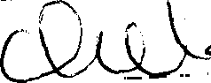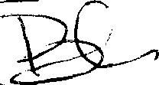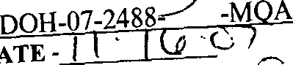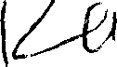BOARD OF PSYCHOLOGY BYE
Final Order NO. DOH-07-2488
-M A
DATE -

CASE NO.: 2006-38001
LICENSE NO.: PY 5917

Deputy Agency Clerk

THEODORE G. WILLIAMS, Ph.D.,

Respondent.

FINAL ORDER ACCEPTING STIPULATION

Theodore G. Williams, Ph.D., (hereinafter “Respondent”), is licensed as a psychologist by the Board of Psychology (hereinafter “the Board"). The Department of Health (hereinafter “the Department”) filed an Administrative Complaint against Respondent on May 31, 2007. Following the filing of Department’s Administrative Complaint, a copy of which is attached hereto as Exhibit “A” and incorporated by reference into this Final Order, Respondent and the Department entered into a Stipulation settling all issues in the case pursuant to § 120.57(4), Florida Statutes, with the exceptions of identifying the area in which Respondent shall complete the six penalty hours of continuing education and the exact amount of administrative costs to be paid. The Board reviewed the case and the Stipulation at its duly noticed public meeting held in Tampa, Florida, on October 26, 2007, at which time Respondent was present and represented by Robert H. Woody, Esquire. The Department was represented by Cynthia L. Jakeman, Esquire. The Board accepted the Stipulation, which is attached as Exhibit “B” and incorporated by reference into this Final Order.
WHEREFORE, the Board hereby accepts the Stipulation, settling all matters in this case consistent with the terms of the agreement between the parties, and Respondent is hereby ORDERED to abide by the terms of the Stipulation, complete the six penalty hours of continuing education (Paragraph 5, Page 3 of the Stipulation) in the area of laws, rules, and ethics, and pay $3,982.20 in administrative costs. This Final Order shall be placed in and made a part of Respondent’s official records.

This Final Order shall become effective upon filing with the Clerk for the Department of Health. DONE AND ORDERED, this / day of *“ 2007.
BOARD OF PSYCHOLOGY
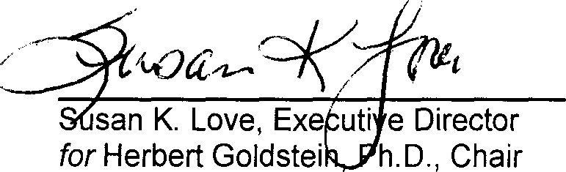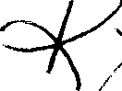

san K. Love, Exe uti e Director
for Herbert Goldstei h.D., Chair

NOTICE OF RIGHT TO APPEAL

THIS ORDER CONSTITUTES FINAL AGENCY ACTION AND MAY BE APPEALED BY ANY PARTY PURSUANT TO SECTION 120.68, FLORIDA STATUTES, AND RULES 9.110 AND 9.190, FLORIDA RULES OF APPELLATE PROCEDURE , BY FILING A NOTICE OF APPEAL CONFORMING TO THE REQUIREMENTS OF RULE 9.110(D), FLORIDA RULES OF APPELLATE PROCEDURE, BOTH WITH THE APPROPRIATE DISTRICT COURT OF APPEAL, ACCOMPANIED BY THE APPROPRIATE FILING FEE, AND WITH THE DEPARTMENT'S CLERK OF AGENCY PROCEEDINGS, WITHIN THIRTY (30) DAYS OF RENDITION OF THIS ORDER.

CERTIFICATE OF SERVICE

I HEREBY CERTIFY that a true and correct copy of the foregoing Final Order has been provided by United States Mail to Theodore G. Williams, III, Ph.D., 430 SW California Avenue, Stuart, FL 34994; Robert H. Woody, Esquire, P.O. Box 34880, Omaha, NE 68134-0880; and by Inter-Office Mail to Cynthia
L. Jakeman, Esquire, Department of Health, Prosecutorial Services Unit, 4052 Bald Cypress Way, Bin C- 65, Tallahassee, FL 32399-3265, and Mary Ellen Clark, Assistant Attorney General, Administrative Law Section, PL-01 The Capitol, Tallahassee, Florida 32399-1050 this / day of
, 2007.
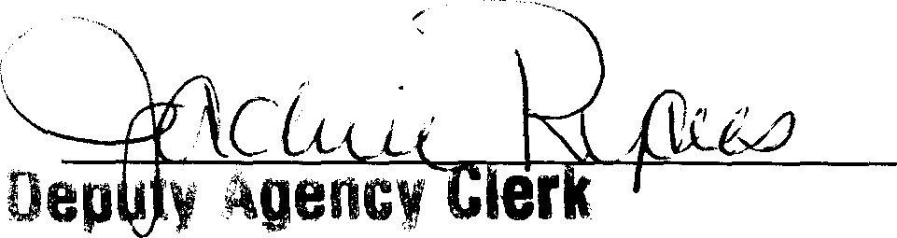

STATEOFFLORIDA DEPARTMENTOFHEALTH

DEPJ\RTNENT OF HEALTH,

Petitioner,
v.
THE£IDORE G. WILLIAMS, Ph.D.,
Respondent.

c

CASE NO. 2006-38001

ADMINISTRATIVE COMPLAINT

COMES NOW, Petitioner, Department of Health, by and through its undersigned

counsel, and files this Administrative Complaint before the Board of Psychology against the R‹°spondent, Theodore G. Williams, Ph.D., and in support thereof alleges:
- Petitioner is the state department charged with regulating the practice of psychology pursuant to Section 20.43, Florida Statutes; Chapter 456, Florida Statutes; and Chapter 490, Florida Statutes.
- At all times material to this Complaint, Respondent was a licensed psych‹aIogist within the state of Florida and was issued license number PY 5917 on December 18, 1998.
- Respondent’s address of record is 382a S.W. Coquina Cove Way, Apt. 208, Palm ‹lily, Florida, 34990.
- GF was referred to the Respondent for an evaluation in regard to a Social Security disability claim.

Exhibit ‘A"

J:\PSIJ\Allied Health\Cynthia Jakeman\Board of Psychology\Cases\Williams, Theodore, Ph.D\T. Williams AC.doc

- On or about August 16, 2006, GF was seen by JK, who worked for the Respc›ndent.
- JK is not IiCensed pursuant to Sections 490 or 491, Florida Statutes.
- JK conducted a psychological evaluation of GF through an interview and
ment‹iI status examination of ‹2F.
- JIC diagnosed GF with depressive disorder, NOS and alcohol dependence, in ren issicn ten (10) years by self report.
- Respondent delegated to JK, professional responsibilities that JK was not qualified by training or experience to perform when Respondent permiKed UK to evaIu‹ te and diagnose GF.
- The Respondent failed to obtain written informed consent fr‹›m GF concerning all aspects of servi(:es including assessment and therapy.
- Respondent failed to conduct a face to face clinical interview of GF.
COUNT ONE
- Petitioner realleges and incorporates paragraphs one (1) through eleven
(11) as if fully set forth herein.

- Section 490.009(1)(w), Florida Statutes (2006), provides that violating any provision of this chapter or chapter 456, or any rules adopted pursuant thereto, constitutes an act for which disciplinary action may be taken.
- Rule 64B19-19.0025(2), Florida Administrative Code provides that a psychologist must obtain written informed consent from a patient/client concerning all aspects of services including assessment and therapy.

J:\PSU\Allied Health\Cynthia Jakeman\Board o( Psychology\Cases\Williams, Theodore, Ph.D\T. Williams AC.doc

- Respondent violated Section 490.009(1)(w), Florida Statutes (2006), throu‹gh a violation of Rule 64B19-19.0025(2), Florida Administrative Code, by failing to obtain written informed consent from GF concerning all aspects of services incl\›Jing assessment and therapy.

Based on the foregoing, Respondent violated Section 490.009(1)(w), Florida Statutes (2006), by violating Rule 64B19-19.0025(2), Florida Administrative Code, by failing to obtain written informed consent from GF concerning all aspects of services including assessment and therapy.
COUNT TWO

- Petitioner realleges and incorporates t›aragraphs one (1) through eleven
(11) as if fully set forth herein,

- Section 490.009(1)(s), Florida Statutes (2006), subjects a licensee to discipline for delegating professional responsibilities to a person whom the licensee knows or has reason to know is not qualified by training or experience mo perform such responsibilities.

Respondent violated Section 490.009(1)(s), Florida Statutes (200d), by
delegating to JK, professional responsibilities that JK was not qualifiecl by training or experience to perform, when Respondent permitted JK to evaluate and diagnose GF.
- Based on the foregoing, Respondent violated Section 490.00s(1)(s), Florida Statutes (2006), by delegating to JK, professional responsibilities that JK was not qualified by training or experience to perform, when Respondent permitted JIC to evalu‹zte and diagnose GF.
J:\PSU\*.IIied Health\Cynthia Jakeman\Board of Psychology\Cases\Williams, Theodore, Ph.D\T. Williams AC.due 3

COUNT THREE

- Petitioner realleges and incorporates paragraphs one (1) through eleven
(11) as if fully set forth herein.

- Section 490.009(1)(r), Florida Statutes (2006), provides that failing to meet the minimum standards of performance in professional activities when measured again‹›t generally prevailing peer performance, including the undertaking of activities for which the licensee is not qualified by training or experience, constitl tes an act for which disciplinary action may be taken.
- Respondent failed to meet the minimum standards of performance in profer:sionaI activities when measured against generally prevailing peer performance in one or more of the following ways:
  - By failing to obtain written informed consent from GF concerning all aspects of services including assessment and therapy;
  - By delegating to UK, professional responsibilities that JK was not qualified by training or experience to perform, when Respondent permiKed JK to evaluate and diagnose GF; or
  - By failing to conduct a face to face clinical interview of GF.

- Based on the foregoing, Respondent violated Section 490.00s(1)(r),

Florid:a Statutes (2006) by failing to meet minimum standards of erformance in profe»sionaI activities when measured against generally prevailing peer performance,

J:\PSIJ\*.llied Health\Cynthia Jakeman\Board of Psychology\Cases\Williams, Theodore, Ph.D\T. Williams AC.doc

including the undertaking of activities for which the licensee is not qualified by traini^s or ex:›erience.
WHEREFORE, the Petitioner respectfully requests that the Boar‹1 of Psychology enter an order imposing one or more of the following penalties: permanent revocation or suspension of Respondent’s license, restriction of practice, imposition of an administrative fine, issuance of a reprimand, placement of the Respondent on probation, corrective action and/or any other relief that the Board rleems appropriate.

SIGNED thisha// ’day of

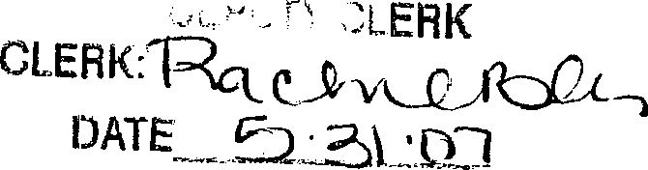

PCP L)ate: 5-22-07
PCP flemhers: Rivas-Vazquez/Perry
, 2007.
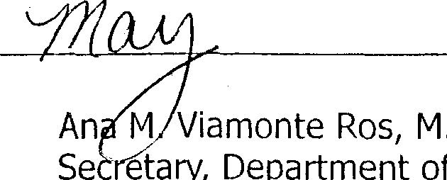
An N Viamonte Ros, H.D., M.P.H.
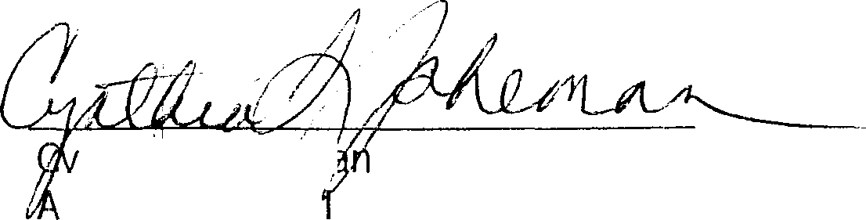
Se Mary, Department of Health

, nthia L. Jake’m‹
‘ssistant Genera Counsel Florida Bar # 0714690 Department of Health Prosecution Services Unit

4052 Bald Cypress Way, Bin C-65
Tallahassee, FL 32399-3265
(850) 245-4640 voice
(850) 245-4682 FAX

J:\PSU\/ llied Health\Cynthia Jakeman\Board of Psychology\Cases\Williams, Theodore, Ph.D\T. Williams AC.dcc 5

NOTICS OF RIGHTS
Respondent has the right to request a hearing to be conduct:ed in accordance with Section 120.569 and 120.57, Florida Statutes, to be represented by counsel or other quaWGed representaGve,to presentevidence and argument, to call and cross-examine witnesses and to have subpoena and 'subt›oena duces tecum issued on his or her behalf if a hearing is requested.

NOTICE REGARDING ASSESSMENT OF COSTS

Respondent is placed on notice that Petitioner has incurred costs reIat‹•d to the investigation and prosecution of this matter. Pursr‹ant to Sect:ii›n 456.072(4), Florida Statutes, the Board shall assess costs related to the investigation and prosecution of a disciplinary matter, which may incl«de attorney hours and costs, on the Respondent in addition to any other discitiline imposed.

J:\PSU\/\llied Health\Cynthia Jakeman\Board of Psychology\Cases\Williams, Theodore, Ph.D\T. Williams AC.d‹›c

08/24/2007 12:54 4024961002 ROBERT HOODY

STATE OF FI ORIDA DEPARTMENT OF HEALTH _
DEPARTMENT OF HEAI TH,
Petitioner,
PAGE 03

*.
TIIEODORE G. WILLIAMS, Ph.D.,

Respondent.
CASE NO. 2006 .88001

SETJ J fiMENT STIPULATION
Pursuant to Section 120.57(4), Florida Statutes, the above named panies hereby offer this Stipulation to the Board of PsyAology (heieinafta “ Board” ) as disposition of the Administrative Complaint filed in this cause and incorporated herein by reference, in lieu of any other administrative proceedings, The terms herein become effective only if and when a Final Order accepting this Stipulation is issued by the Board and filed. If this Stipulation is rejected, it, and its presentation to the Board, hall not be used against either party.
STIPULATED FACTS
- Respondent is and has been at alI times material hereto a licensed psych ologist or seeking licensure as a psychologist within the state of Florida and was issued license number PY 5917 on December 18, 1998. Respondent’s address of record is 3821 S.W. Coquina Cove Way, Apt., 208, Palin City, Florida, 34990.
- The Respondent was charged by an AdmtnlStrative Complaint, fded by the Department of Health (hereinafter “Department”) and properly served upon Respondent with violations of Chapters 456 and 490, Florida Statutes. A true and correct copy of the Administrative Complaint is attached hereto and incorporated by reference as Exhibit “A”.
- Respondent neither admits nor denies the factual allegations in the Administrative Complaint and is entering into Its Stipulation for the purpose of settlement in these administrative proceedings only.

Exhibit “B”

Page i Initiated by Re.«pondent

68/ 24/ 2887 12: 54 48249610B2 ROBERT GOODY PAGE 04

STIPULATED LAW
- Respondent admis that, in Respondent’s capaaty as a licenced psychologist, Respondent is subject to thc provisions of Chapters 456 and 490, Florida Statutes, and the jurisdiction of the Department of Health and tlic Board
- Respondent admits that the stipulated facts, if proven true, constitute violations of laws as alleged in the Admini.strative Complaint.
- Respondent admits that the Stipulation is a fair, aprrorriate, and reasonable
resolution to this pending matter.
PROPOSED )3 OAITION

- APPEARANCE: The Respondcnt is required to be present when this settlement stipulation is presented to the Board for approval.
- FINE: The Board shall impose an administrative fine of three thousand dollars ($3000 00) against the license of thc Respondent. The Respondent acknowledges that the timely payment of the FINE is respondent’s legal obligation and respon.‹Ability. The FINE shaft be paid by check or money order to the Board of Psychobgy within 90 ‹rays of the filing of tire Final Order in this matter, and sent to: Department of Health, HMQAMS/Climt Services, P.O. Box 6320, Tallahnssee, Florida 32314-6320, Attn.: Psydiology Compliance Officer.
- S'fS: Pursuant to Section 45G.072(4), Florida Statutes, Respondent will reimburse the Dcpartment actuai costs associated with the iuwstigation and prosecution of this matter. Actual costs will be determined ai the time this Stipulation is presented to the Board. Thc respondent acknowledges that the timely payment of the costs is respondent’s legal obligation md re.sponsibility. The ACTUAJ COSTS, as indéated in fin Final Ords, shall be paid by chef or money ords to the Board of PsyAology within 90 days of the filing of the Final Order in this maker, and sent to: Department of Health, HMQAMS/Climt 5ervices, P.O. Box 6320, Tallnhassee, Florida 32314•6320, Attn.: Psychology Compliance Officer.
- AFFIJ)AVIT: The Respondent shall, within thirty (30) days following the filing of the Final Order adopting and incorporating this Stipulation, provide the Board office with a signed and notarized affidavit stating that Respondent has read and understands the laws and rules p•oveming the practice of psychology in the State of Florida, including Chapters 456 and 490,

Page 2 Initiated by Re.spondcnt

08/ 24/ 2807 12: 54 4024961002 ROBERT GOODY PAGE BS

Florida Statutes, and Chapter 64B-19, Florida Administrative Code, Rules of the Board of Psychology, and the importance of adhering to same.
- CONTINUIN_G EDUCATION: Respondcnt shall, within one (1) year of the filing of thg ftnal order adopting and incorporating this stipulation, successfully complete and document to the Board a minimum of six (6) hours of contnuing educatlon in an area or areas to be determined by the Board. These continuing education hours shall be in addition to the continuing
education hours nomially required for renews of Respondent's license. Home study courses will not be accepted to saisfy this condition unless specifically authorized by the Board. Verification of successful completion and documentation of course content shall be timely submitted to: Department of Health, HMQAMS/Clint Services/Din #C01, 4052 Bald Express Way, Tallahassee, Florida 32399-3251, Attn.: Psydiology Compliance Office.
- ADDED: Res}x›ndentagrtes to keep current residence and practice addmssss on file with the Board. Resjx›ndentshai1 notify the Boatd within ten (10) days of any changes of said adHsses.
- Respondent shall not in the future violate Chapters 456 and 490, Florida Statutes,
the rules promulgated pursuant thereto, or any other state or federal law, rule, or regulation relatinp•
to the practice or to the ability tp engage in the practice of psycholop•y.
- It is expressly understood that a violation of the terms of this Stipulation shall be considered a violation of a Final Order of the Board, for which disciplinary action may be initiated pursuant to Chapters 456 and 490, Florida Statutes.
- It is expressly understood that this Stipulation is .subject to approval of the Board and the Department, and has no force or effect until the Board bases an Order upon it.
- The Re.‹pondent, for the purpose of avoiding further administrative action with respect to this particular case, executes this Stipulation. In this regard, Respondent authorizes the Board to review and examine all investigative file materials concerning Respondent prior to or in conjunction with consideration of this Stipulation, Respondent agrees to support this Stipulation at the time it is presented to the Board and shall offer no evidence, testimony, or argument that disputes or contravene.s any stipulated fact or concluslon of low. Furthermore, should this SEpulation not be accepted by the Board, it is agreed that the presentation and consideration of this

Page 3 Initial.ed by Respondent

88/24/2887 12:54 4824961B82 ROBERT GOODY PAGE B6

Stipulation and other documents and matters by the Board .shall not iinfauly or illegally prejudice the Board or any of its members from further participation, consideration or resolution of these proceedings.
- The Respondent and the Department fully understand that this Stipulation arid subsequent Final Order incorporating same will in no way preclude additional proceedings by the Board and/or Department of Health against the Respondent for acts or omit.sions not spmifically set font in the Adminiszatiw Complaint, attached hereto as Exhibit “A”, issued in this cause.
- The Respondent wnives the right to seek attorneys’ fees and/or costs from the
Department of Health in connection with this disciplinary proceeding.
- Upon the hoard’s adoption of this Sti,pu1ation, Respondent expressly waives ali further procedural steps, and expressly waives all rights to seek judicial review of or to otherwise challenge or contest the vali‹iity of this Stipulation and the Final Order of the Board incorporsnng said Stipulation.
WHEREFORE, the parties hereby request the Board to enter a Final Order accepting and
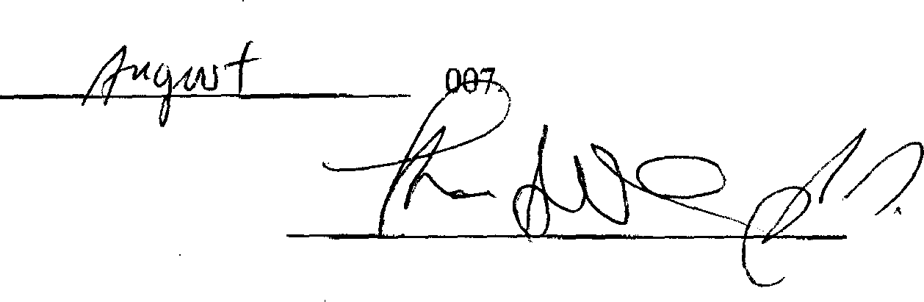
implementing the terms contained herein.

SIGNED this day of
,2

Theodore Williams, Ph.D. Case number 200C38001

STATE OF

COUNTY OF
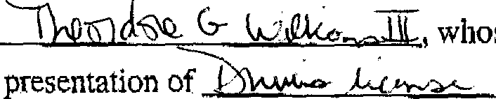
Before me personally appeared $W G' , whose identity is known to me by personal knowledge or by presentation of I as identification (type of identificatio»), and who acknowledges that hls or her signature appears above.
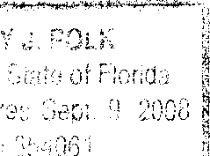Sworn to or affirmed before me this May of , 2007.
Page 4 ITit ialed by Rsspoudent

88/ 24/ 2887 12: 54 4624961882 PAGE B7

Notary Public by Commission Expires

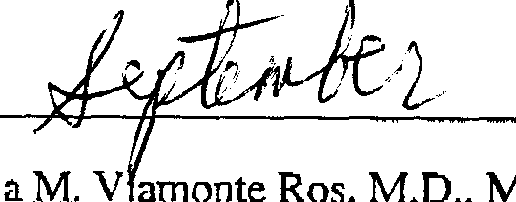
APPROVED dais y of “ , 2007.
Ana M. Y amonte Ros, M.D„ M.P,H,
State Surgeon General

By:

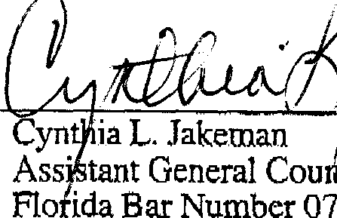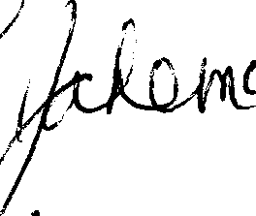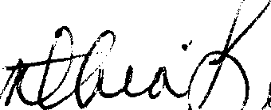yn ia L. ,Jakeman

Ass’ tant General Con el Flo ida Bar Number 0714690 Department of Health Prosecution Services Unit
4052 Bald Cypress Way, Bin C-65 Tallahassee, FL 32399-3265
(850) 245-4640, Ext. 8133 office
(850) 245-4682 FAX

Page 5 lnitialcd by Respondent

